**User Testing - Lookback Plan**

**Introduction**

## Lookback is a program that allows us to test completed components on On Key with internal and external users and will allow us to see how they are using On Key. This would also show us where there are possible red flags in terms of usability, so that we can take the component back into design or dev to see how we can better it.

## Lookback allows us to test with Users outside of our South African borders. This will give us an indication of how our international users use the system.

**Talk with your users, face to face**

## Ask questions, get users responses, and let users share their screen, from anywhere in the world.

**When do we use Lookback?**

## Once a design is completed the design must first go through a Maze user test as a proof of concept, and that the user understands what they can achieve when using this component. Once that is complete and the designer will handover to a developer, the developer will complete that component. Once completed it will then go into Lookback and with the help of the OK+ Product Owner we will identify users that we can contact to do a Live User Test with. Every project put into Lookback has an unique Live invite link that can be sent to as many users as you like.

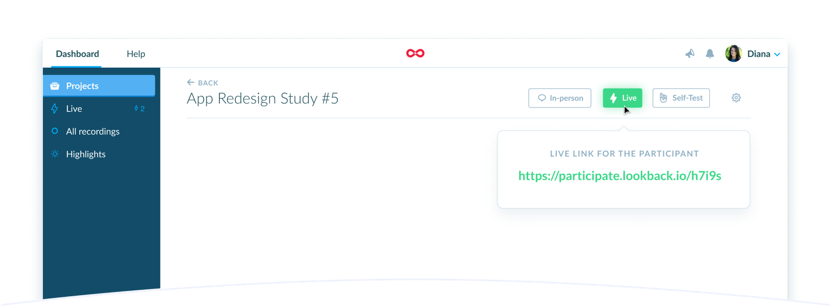The use of lookback works on mobile and desktop.

**Components that are ready for testing:**

The items that are ready for testing will be discussed with the OK+ Product Owner and analysts as we go along and will be added to a table like the example below, according to priority.

|  |  |  |
| --- | --- | --- |
| **Component** | **Priority** | **Tested** |
| Asset Type Tree | High | No |
| Properties Panel | High | No |
| Menu | Medium | No |
| OK Side Panel | Low | No |

**Selecting the users**

**Internal User to test with**

**Personas:**

The design team will create various personas to cover all possible users of On Key, this will be done with the assistance of the various product owners, product managers, product lessons or any stakeholder. This will allow us to get inside information to make sure that we cover all the relevant information.

**Collaboration Groups:**

**Tetra Pak:** Evette Meyer, Nevek Govender, Mike Els, Johan Hendricks

**Pragma:** Roald van Zyl Smit, Nicolaas Jackson

**R&D:** Mauritz Zastron, Darren White, Dirk Janse van Rensburg, Stefan Swanepoel, Ilse Kieser,

Zinhle Boltina, Juan Vermeulen

This list will increase as we do more testing and on request from some of the product owners/managers etc.

**­**

Sample of persona mapping

**How it works**

**User Side**

1. **User receives the link**

A unique Live link will be sent to the user in which we’ll walk them through the setup process.

**2. User installs the app**   
 We will detect the device and get the right app installed automatically.

1. **Ready to Test**

Users are now ready for a Live Session.

**How it works**

**Testing Side**

For the test to be structured well, we need to have a script ready to be 100% sure of the questions that you are going to ask the user. These questions should be goal driven type questions that will put the user in a space where he / she needs to get to an end point on the system.  
  
 **e.g.**   
 1. On the Meters page where would you go to add a new meter.   
 or  
 2. Please show us the how you will create a new meter using OK+

The script will also need to pass through the Product Owner or one of the analysts to be sure that the right questions are being asked for that specific component.  
  
The script will differ from component to component as you will need to get different outcomes from different components.   
  
Having the script ready before you do the testing will also get you ready if there are any questions that the user asks and can serve as a means of preparation for the tester.

**­**

Take not to observe the user’s facial expressions as you do the testing. If they have a confused expression, pause and ask what is bothering them as this can be very helpful.   
  
 Please note the user has the option to not share their video.

**Collaboration**

**Invite the team to observe the test**Share the research. Invite colleagues and stakeholders to watch interviews in real-time. In-house or out-of-office.

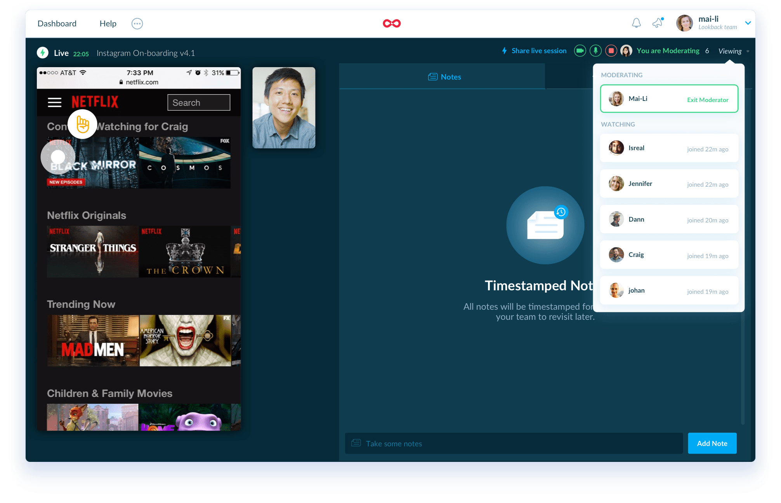

All the recording is saved on the dashboard and can also be shared with colleagues and stakeholders. This also allows us to refer back to recordings and re-watch those important moments.

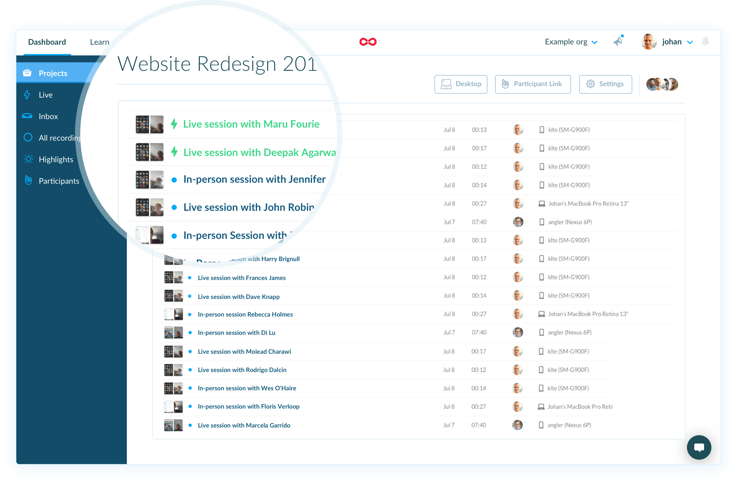

**Feedback and Reporting**

**Feedback**  
Because you can chat to the user while you are busy testing you will have to make notes / comments on your side to make sure you get all the valuable feedback and concerns for their side.   
  
If the session is too fast and you can’t make notes / comments during the session you can go back to the recording afterwards and add not on the video to share with relevant parties

**Reporting**Like in any user testing we want to put a measurable on a test to say that this specific component got X percentage to confirm that the component is good to go or that it still needs some attention. By using the SUS (System Usability Scale) method we will achieve just that.

When a SUS is used, participants are asked to score the following 10 items with one of five responses that range from Strongly Agree to Strongly disagree:

1. I think that I would like to use this system frequently.
2. I found the system unnecessarily complex.
3. I thought the system was easy to use.
4. I think that I would need the support of a technical person to be able to use this system.
5. I found the various functions in this system were well integrated.
6. I thought there was too much inconsistency in this system.
7. I would imagine that most people would learn to use this system very quickly.
8. I found the system very cumbersome to use.
9. I felt very confident using the system.
10. I needed to learn a lot of things before I could get going with this system.

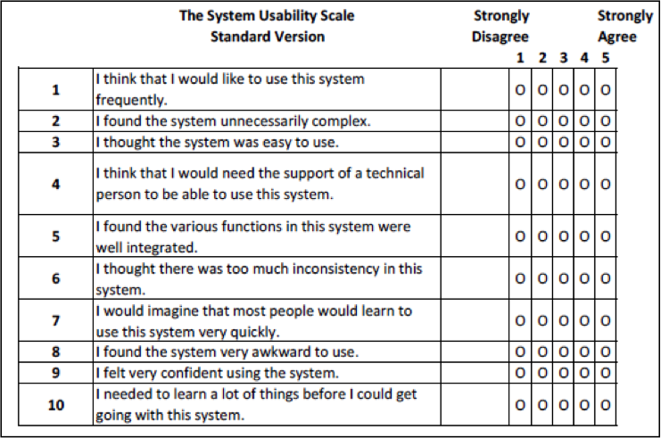

**Interpreting Scores**

Interpreting scoring can be complex. The participant’s scores for each question are converted to a new number, added together and then multiplied by 2.5 to convert the original scores of 0-40 to 0-100.  Though the scores are 0-100, these are not percentages and should be considered only in terms of their percentile ranking.

Based on research, a SUS score above a 68 would be considered above average and anything below 68 is below average, however the best way to interpret your results involves “normalizing” the scores to produce a percentile ranking.

The **On Key** system should always be above average, so in saying that, a pass for either Maze or Lookback should always be above 68.



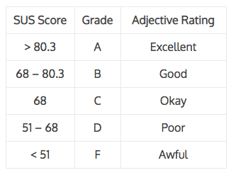

Once this has been done we know that **On Key** will be excellent.­

**Note:   
This is something the analysts can aslo use to analyse something in OK5  
 to help us improve that in OK+**

**THANK YOU**